
CSA05-DATABASE MANAGEMENT SYSTEMS

DBMS LAB - Experiment 6

AIM
To view the records from the tables using SELECT commands with BETWEEN, IN, Aggregate functions.

DESCRIPTION
The BETWEEN operator tests a value within a range. The IN operator checks whether a value matches any value in a specified list. Aggregate functions include AVG, COUNT, SUM, MIN and MAX.

1. Select Database
USE collegedb;

2. Display Existing CoffeeShop Records
SELECT * FROM CoffeeShop;
OUTPUT:
Screenshot:
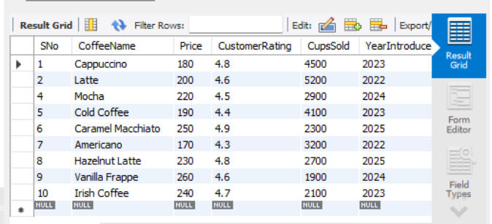

3. IN Operator – Medium or Large Coffees
SELECT *
FROM CoffeeShop
WHERE Size IN ('Medium', 'Large');
OUTPUT:


4. BETWEEN Operator – Price Between ₹180 and ₹250
SELECT *
FROM CoffeeShop
WHERE Price BETWEEN 180 AND 250;
OUTPUT:


5. Average Price of All Coffees
SELECT AVG(Price) AS Average_Price
FROM CoffeeShop;
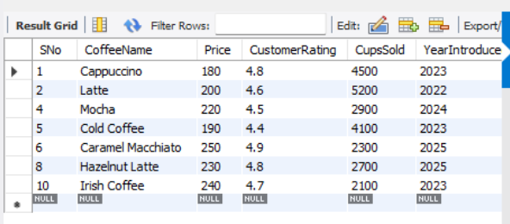

6. Maximum and Minimum Price
SELECT
MAX(Price) AS Maximum_Price,
MIN(Price) AS Minimum_Price
FROM CoffeeShop;
OUTPUT:
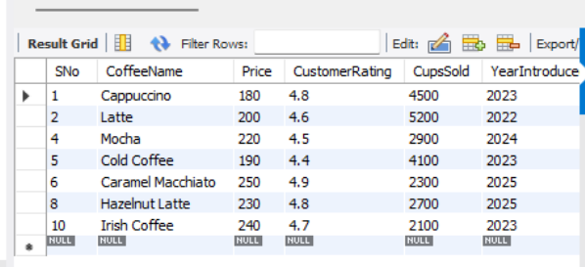
____________________________________________________________

7. Maximum, Minimum and Average Price for Each Size
SELECT
Size,
MAX(Price) AS Maximum_Price,
MIN(Price) AS Minimum_Price,
AVG(Price) AS Average_Price
FROM CoffeeShop
GROUP BY Size;
OUTPUT:
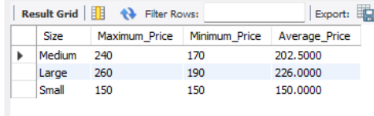

8. Average Price for Each Size
SELECT
Size,
AVG(Price) AS Average_Price
FROM CoffeeShop
GROUP BY Size;
OUTPUT:
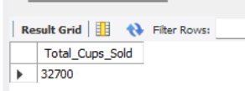
____________________________________________________________

9. Total Cups Sold
SELECT SUM(CupsSold) AS Total_Cups_Sold
FROM CoffeeShop;
OUTPUT:

____________________________________________________________

10. Number of Coffees in Each Size
SELECT
Size,
COUNT(*) AS Number_of_Coffees
FROM CoffeeShop
GROUP BY Size;
OUTPUT:
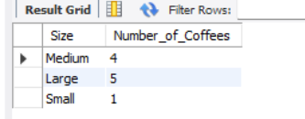
____________________________________________________________

11. Number of Coffees Introduced in Each Year
SELECT
YearIntroduced,
COUNT(*) AS Number_of_Coffees
FROM CoffeeShop
GROUP BY YearIntroduced;
OUTPUT:
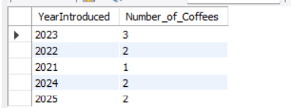

RESULT
Thus, the SELECT commands using BETWEEN, IN and Aggregate functions were successfully executed on the CoffeeShop table.

